

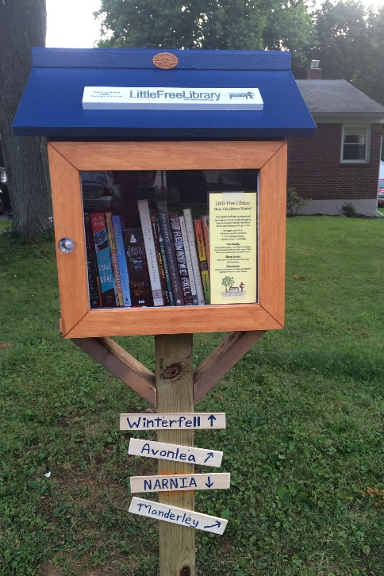

(INSERT YOUR
PHOTO HERE)

Announcing Little Free Library #(INSERT YOUR CHARTER NUMBER)
Join us for the Grand Opening!
HOST:
WHEN:
TIME:
ADDRESS:
(INSERT ADDITIONAL DETAILS HERE)
Here’s how it works:
- We initially stock the Little Free Library with a variety of books
- You stop by and take whatever catches your eye
- You bring books to contribute when you can

Visit www.littlefreelibrary.org for more information

